Project Report

|  |  |
| --- | --- |
| Project Title | Design, Develop, Implement, Test & Document Used Car Sales Portal Website |
| Module Name | Application Development & Process |
| Course Name | Applied Degree in Software Engineering |
| Project Start Date | 25 November 2022 |
| Project Submission Date |  |

|  |  |  |  |
| --- | --- | --- | --- |
| Student name | | Assessor name | |
| Wildan Luqmanul Hakim | |  | |
| Date issued | Completion date | | Submitted on |
| 21 November 2022 | 13 December 2022 | | 13 December 2022 |
|  | |  | |
| Project title | Design, Develop, Implement, Test & Document Used Car Sales Portal Website | | |

|  |
| --- |
| Learner declaration |
| I certify that the work submitted for this assignment is my own and research sources are fully acknowledged.    Student signature: Date: 13 December 2022 |

Content

1. Project Background
2. Project Objectives
3. Project Requirement Specifications
4. Task 1
5. Task 2
6. Task 3
7. Task 4
8. Task 5
9. Task 6
10. Task 7
11. Task 8

1. Project Background

Users will be able to register in the ABC Cars portal using the Registration Page. Users of the portal can search for Cars based on their budget and model name. After searching for them, users will be able to view the Car information. After logging in, users can post Cars for sale and update their own profiles.

Whereas the administrator can log in to the portal, View List of Registered Users can update or delete user information. Make a User the Administrator. They should update their personal information. They can also add, update, or delete car details registered in the portal. Admin can also search for a car by price range and model name.

1. Project Objective
   1. List of Objective

There are 2 types of users in this Used Cars Sales portal. They are

* Users
* Administrator

**Users should be able to perform following functions in the portal**

* Register in the Portal
* Login to the Portal
* Post a Car for Sale along with Picture upload
* Deactivate an Existing car sale
* Update their Profile after logging in.
* Book an appointment for test drive
* Post the bidding price

**Administrators should be able to perform the following functions in the portal**

* Register in the Portal
* Login to the portal
* View List of Registered Users
* Mark a User as Administrator
* Activate / Deactivate a Car post
* Update their profile
* Approve or Deny the users appointment based on the bidding
* Transact the sales if price is right

**Both Users & Administrator**

* Visit Home Page
* View Car Listing
* Search for a Car by Make, Model, Registration Year & Price Range
* About Us Page
* Contact Us Page
  1. Tools & Platform Used

1. Spring Framework
2. MySQL Database
3. phpMyAdmin / mysql client
4. Eclipse IDE for Development
5. Microsoft Word
6. Microsoft Power Point
7. Draw.io
8. Project Requirements Specific
   1. Project Scope

The scope of this project is to create a testing plan and strategy to appreciate the requirements for implementing RBT as a system testing methodology clearly and concisely.

* 1. Non – Functional Requirement

|  |  |  |
| --- | --- | --- |
| **No** | **Requirements** | **Details** |
| 1 | Performance | Determine how well the application performs certain functions under specific conditions. |
| 2 | Availability | Describe how a user can access the system.. |
| 3 | Security aspects | To identify and assess potential vulnerabilities in a system so that attacks can be faced while the system remains operational and not hacked. |
| 4 | Effeciency | To calculate the amount of resources required for a program to perform a specific function. |
| 5 | Loading capacity | To ascertain the behavior of a system under both normal and anticipated peak load conditions |
| 6 | Reliability testing | To thoroughly test the software system to ensure that all defects and faults are identified and corrected. |
| 7 | Database backup | To make a backup of data that can be recovered in the event of a primary data failure. |

* 1. Technical Requirement

1. Database Requirements

MySQL Workbench 8.0

1. Hardware Requirements

* Processor : Intel Core 3GHz (Dual Core 2GHz) or higher.
* RAM : 4 GB (8 GB Recommended)
* Graphic : Nvidia 960M or equivalent
* Disk Space : 2 GB Free Disk Space

1. Software Requirements

* Draw.io
* Google Chrome
* Microsoft Power Point
* Microsoft Word
* MySQL
* Spring Tool Suits (STS)
* Spring.io

1. Task 1

Task Statement

Create the following items Under “Business Process Section” in Project Presentation.

1. Explain the Business Processes the Software is supporting.
2. Document 2 Business Process.
3. Document 2 Module functionality.
4. UI Screenshots.
5. Functionality of each of the Screen.

Solutions

1. **Explain the Business Processes the Software is supporting.**
2. Document 2 Business Process.
   1. Post Car Screen Capture  
      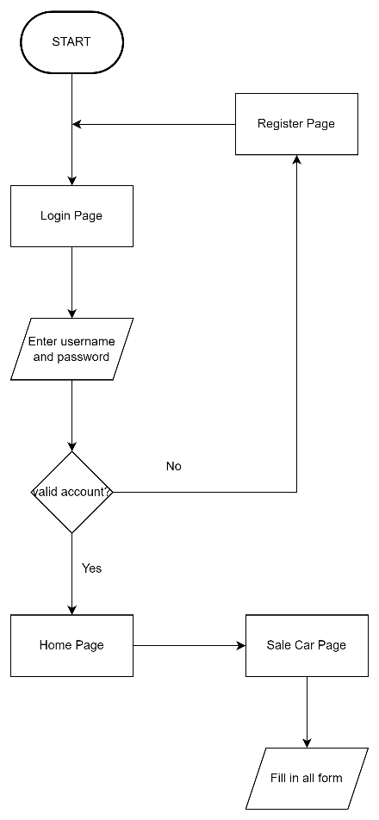
   2. Manage Car Screen Capture  
      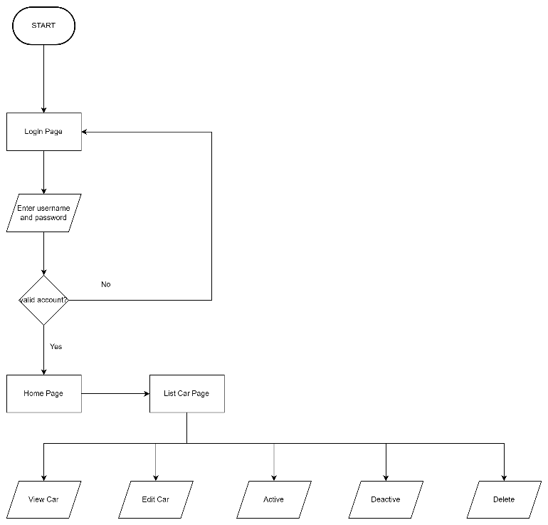
3. **Document 2 Module functionality.**
4. UI Screenshots.
   1. Post Car Screen Capture  
      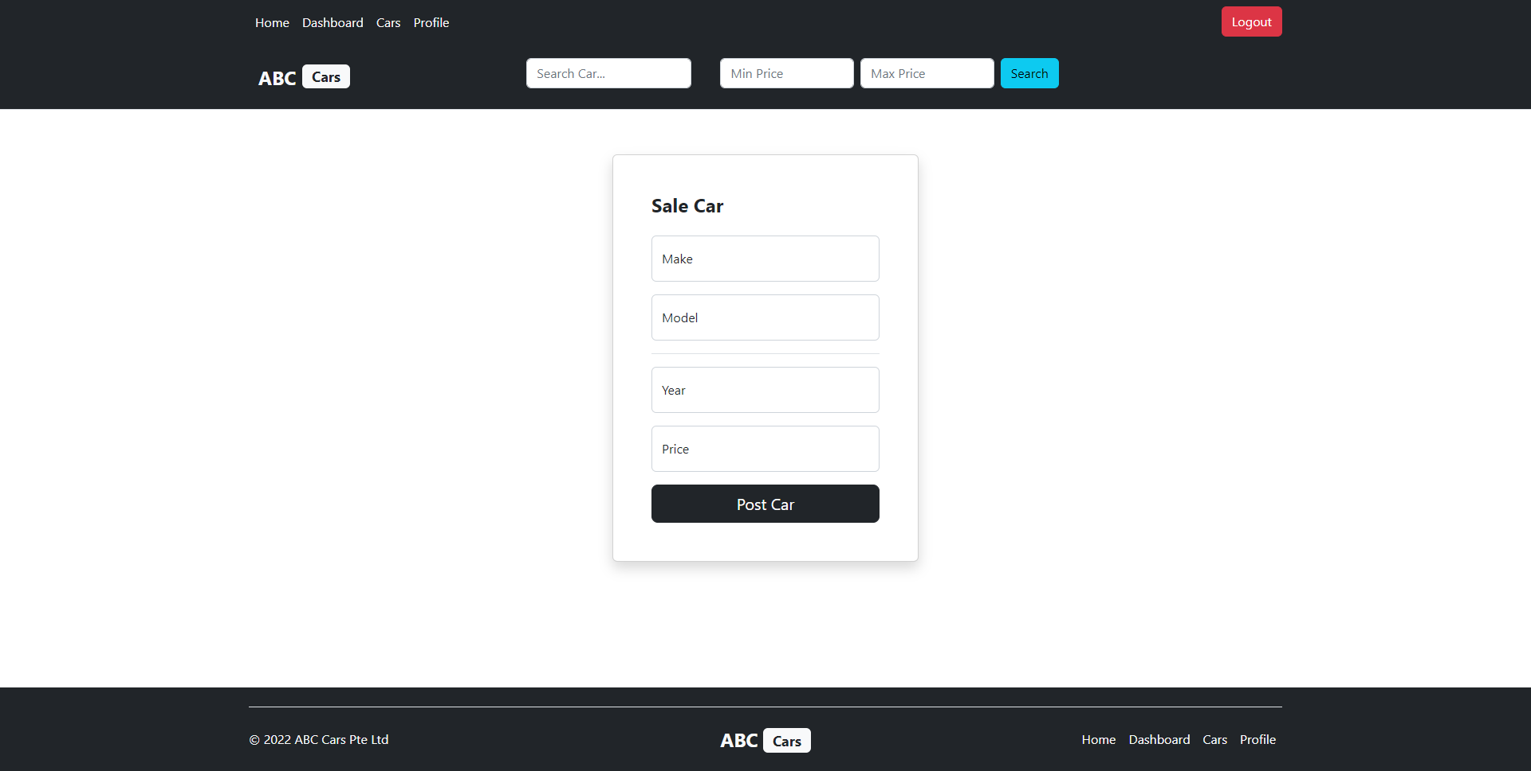
   2. Manage Car Screen Capture  
      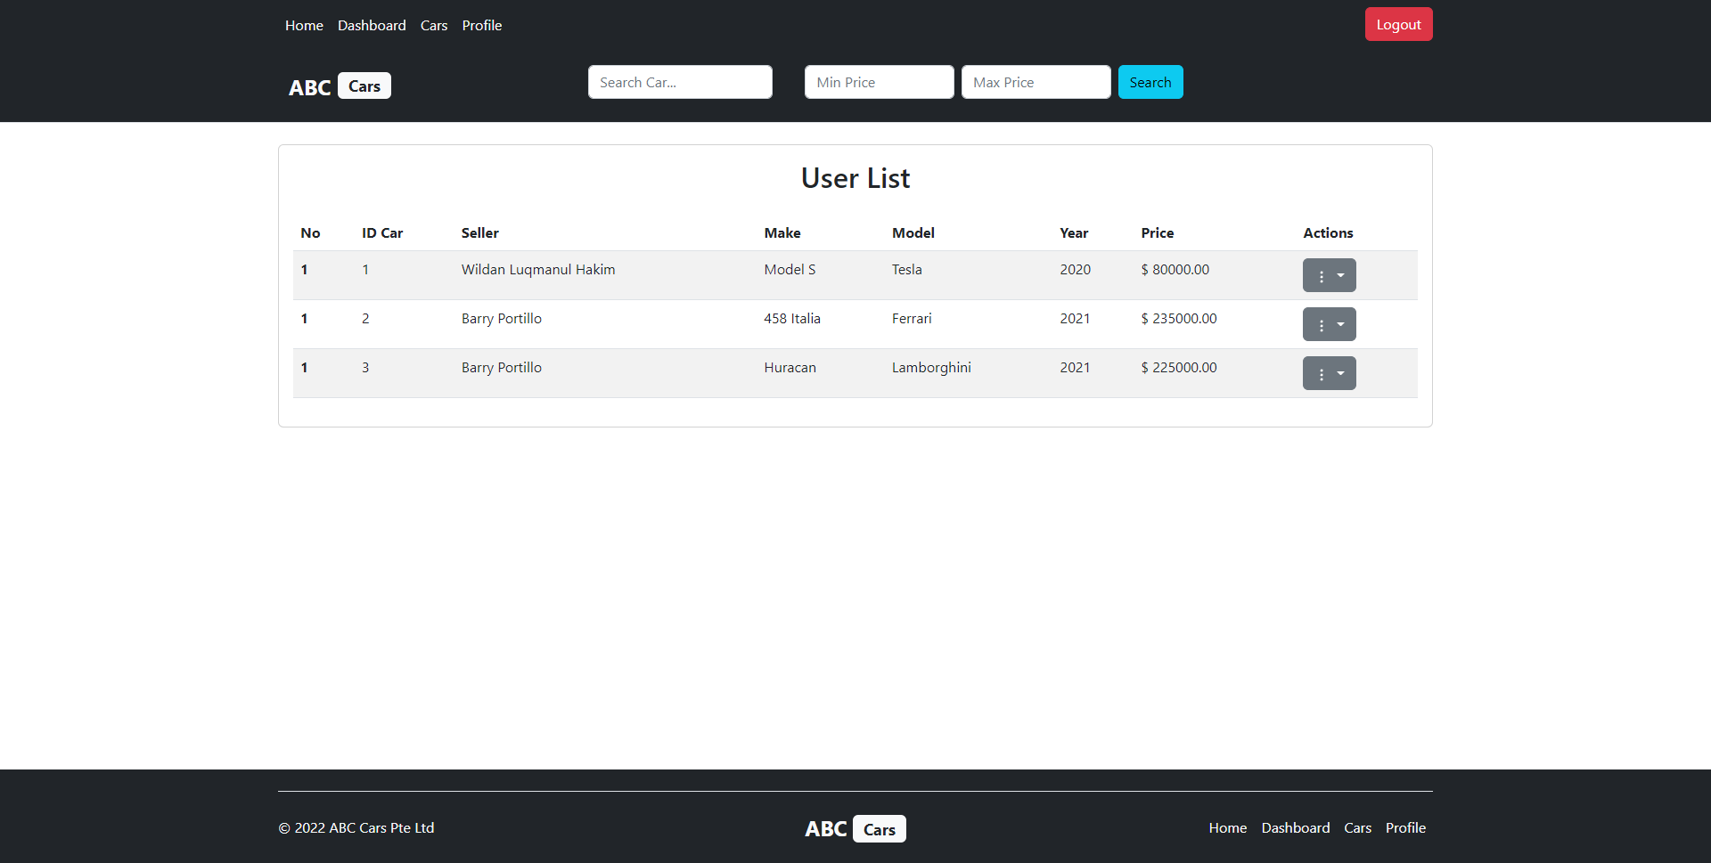
5. Functionality of each of the Screen.

|  |  |  |
| --- | --- | --- |
| **Pages** | **Functionality** | **Image** |
| 1. Post Car Page | Post a car for sale, by filling out the Make Car, Model Car. Year Car, and Price Car | 2.a.a |
| 1. Manage Car Page | Manage all the cars for sale on the website (View Detail Car, Edit Posting Car. Active Car Posting, Deactive Car Posting and Delete Car Posting) | 2.a.b |

1. Task 2

Task Statement

Create the following items in “Project Plan in Project Presentation.

1. Detail the Software Development Methodology to be used for developing system.
2. List the various tasks to be done during various phases.
3. Create the Project Plan detailing the various steps to be carried out along with dates and Timelines.

Solutions

1. **Detail the Software Development Methodology to be used for developing system.**

Development of website application will be using spiral model software development methodology.

**Spiral Model Diagram**

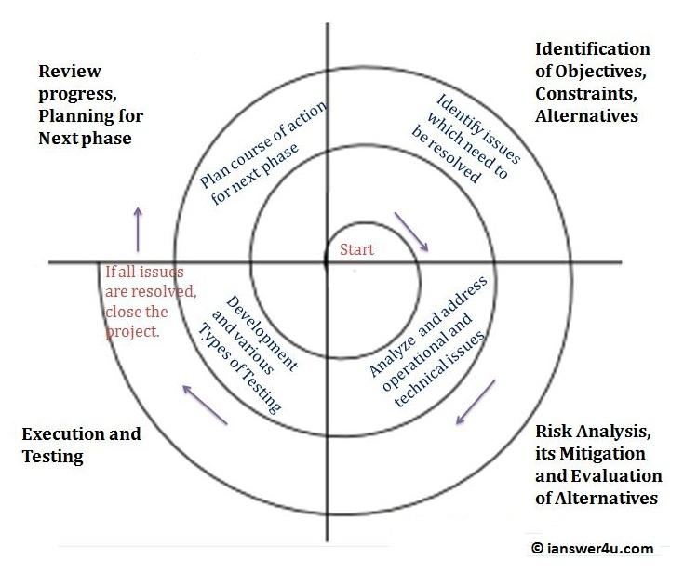

1. **List the various tasks to be done during various phases.**
   * 1. **Planning and Requirement Gathering**
2. Identify our ABC company as a client and stakeholders will be reponded to the project development.
3. Arrange a project kick off meetings from both side and will be lead by the project manager.
4. Gather list of project requirements from the ABC company.
5. Prepare the scope document of the project with project goals what the ABC company envision the result of the project, collect all assumptions that will be discussed during the kick off meeting, define all possible contraints that will be presence during the development process, and review the project scope document with stakeholders that will be sign off by the ABC company.
6. Gather project objective
   * Create a car sale website.
   * Create login and registration function.
   * Develop post car and car bidding function, with the addition function of listing users and car management for admin role.
   * Build a functional database system for car sale website.
7. Plan resources that will be needed during the development by the basic need of our organization, human resources, and technical resources.
8. Estimating total cost of the project including all resources will be needed.
9. Plan the schedule for every phase during the development cycle and finalize it by the agreement with the stakeholders.
10. Test plan preparation for the implementation
11. Preparing the system requirement specifications for the organization and the car sale pages.
12. Prepare service level agreement document to be sign off after the community website deployment.
    * 1. **Risk Analysis**
    1. Analyze every possible risk happen during development.
    2. Prioritize identified risk gathered after analyzing.
       1. **Development and Testing**
13. List of technical requirement

* Hardware requirement
* Software requirement
* Database requirement

1. Prototype

* Business process diagram
* Wireframes
* Storyboard

1. Database design

* Entity relationship diagram design
* Logical diagram design

1. Project implementation

* Create and develop all web pages as per requirements for the car sale website.
* Webpages integration of all created pages.
* Implementing business logic for how the website will works.

1. Project testing

* Review test plan for different types testing.

1. Website deployment

* .
  + 1. **Evaluation**

1. Run various evaluation
2. Gather results
3. Review
4. Create changes if necessary to the system and back to the first phase of the life cycle.
5. Release maintenance user manual procedure.
6. Sign off the service level agreement by ABC company and project manager.
7. **Create the Project Plan detailing the various steps to be carried out along with dates and Timelines.**

|  |  |  |  |
| --- | --- | --- | --- |
| **Phases** | **Activity** | **Start Date** | **End Date** |
| **Planning and Requirement Gathering** | Identify client and stakeholders that will be responded to the website project. | 21 November 2022 | 22 November 2022 |
| Arrange kickoff meeting with client and stakeholders. | 22 November 2022 | 23 November 2022 |
| Gather list of project requirements. |
| Prepare the scope document of the project |
| Gather project objective |
| Plan resources that will be needed |
| Estimating total cost of the project |
| Plan the schedule for every phase | 23 November 2022 | 25 November 2022 |
| Test plan preparation |
| Preparing the system requirement specifications |
| Prepare service level agreement document |
| **Risk Analysis** | Analyze every possible risk happen during development. | 25 November 2022 | 26 November 2022 |
| Prioritize identified risk gathered after analyzing. |
| **Design, Development, & Testing** | Create wireframes | 26 November 2022 | 27 November 2022 |
| Develop prototype | 26 November 2022 | 27 November 2022 |
| Create storyboard | 26 November 2022 | 27 November 2022 |
| Design entity relationship diagram design | 28 November 2022 | 30 November 2022 |
| Logical diagram design |
| Create and develop all web pages as per requirements for the community portal. | 30 November 2022 | 6 December 2022 |
| Webpages integration of all created pages. |
| Implementing business logic for how the website will works. |
| Review test plan for different types testing. | 6 December 2022 | 7 Deccember 2022 |
| Select every pages and functions that will be tested. |
| Website deployment | 7 December 2022 | 8 December 2022 |
| **Evaluation** | Run various evaluation by the public customer of the car sale website. | 10 December 2022 | 11 December 2022 |
| Gather results of the system evaluation or feedbacks from the customers. |
| Review the result of the evaluations by both side from ABC company and our stakeholders. | 11 December 2022 | 12 December 2022 |
| Create changes if necessary to the system and back to the first phase of the life cycle. |
| Release maintenance user manual procedure. | 12 December 2022 | 13 December 2022 |
| Sign off the service level agreement by ABC company and project manager. |

1. Task 3

Task Statement

Create the following items under “Testing Concepts” in Project Report.

1. Explain risk-based testing concepts and requirements with the following details.
2. Stages involved in RBT Model
3. Types of risks and its impact

Solutions

1. **Explain risk-based testing concepts and requirements with the following details.**
2. Stage involved in RBT Model

Risk Based Testing (RBT) is a type of software testing that is based on risk probability. It entails evaluating the risk based on software complexity, business criticality, frequency of use, potential areas with defects, and so on. Risk-based testing prioritizes testing of software application features and functions that are more important and likely to have defects.

3 RBT Stages:

**Risk Identification:** Risk workshops, checklists, brainstorming, interviewing, Delphi technique, cause and effect diagrams, lessons learned from previous projects, root cause analysis, and contacting domain experts and subject matter experts can all be used to identify risks.

**Risk Analysis:** After identifying a list of potential risks, the next step is to analyze them and filter the risks based on their significance. The Risk Matrix is a qualitative risk analysis technique (covered in the next section). This technique is used to calculate the risk's probability and impact.

**Risk Response Planning:** Based on the analysis, we can determine whether the risks necessitate a response. Some risks, for example, will necessitate a response in the project plan, while others will necessitate a response in project monitoring, and still others will necessitate no response at all.

1. Types of risks and its impact

|  |  |  |  |
| --- | --- | --- | --- |
| **Type of Risk** | **Risk Identification** | **Risk Description** | **Impact** |
| Functional | Login Risk | The user's data was not found in the database (invalid login) | Medium Impact |
| Registration Risk | The user's data cannot be entered into the database. | Medium Impact |
| Post Car | The data entered by the user for the car cannot be stored in the database. | Moderate Impact |
| Update Profile | The user's information cannot be updated in the database. | Moderate Impact |
| Manage Car | The car's data in the database cannot be updated. | Moderate Impact |
| Non – Functional | Performance Effiency | The website is unable to perform at expected levels due to poor internal operating practices, technology, and/or external relationships that jeopardize demand for the organization's products or services. | Critical Impact |
| Compatibility | The website is incompatible with a wide range of browsers. | Medium Impact |
| Usability | Due to technical difficulties, the website cannot be accessed. | Critical Impact |
| Security | Because the website is not protected, it is vulnerable. | Critical Impact |
| Database backup and recovery | Failures in backup and recovery that result in data loss | Critical Impact |

1. Task 4

Task Statement

Create the following items under “Test Planning” in Project Report.

1. Establish the test phases of security testing with its prioritization.
2. Develop the detailed test plan with test cases based on quantitative risk analysis.
3. Create a test risk matrix with the evaluation of the impact.

Solutions

1. **Establish the test phases of security testing with its prioritization.**
2. Risk Based Test Strategy in ABC Car Sale website.
3. What is security testing

Security testing is a process that tests how high the security level of an application, namely a web application, is to know the value and level of security and useful recommendations.

1. Types of security testing

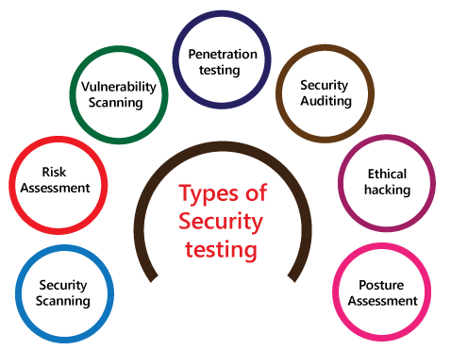

* Vulnerability Scanning  
  Vulnerability scanning is the process of obtaining network vulnerability information by making use of various network scanning tools and vulnerability scanners, such as open ports, server application bugs etc.
* Security Scanning  
  Security scanning is a scan used to find vulnerabilities or unwanted file modifications in web-based applications, websites, networks, or file systems.
* Penetration Testing  
  Penetration Testing is an activity where someone tries to simulate an attack that can be carried out against a certain organization/company network to find weaknesses in the network system.\
* Risk Assessment.

Risk Assessment is an assessment of a risk by comparing it to a predetermined risk level or criteria

* Security Auditing  
  Security Auditing is systematic and measurable technical assessment or evaluation regarding computer security and its applications.
* Ethical Hacking  
  Ethical Hacking is hacking activities carried out to find weaknesses or threats in a computer and network.
* Posture Assessment

Posture assessment is carried out to improve risk management capabilities in companies/organizations.

1. Among test strategies, how to carry out security testing.

ABC Car Sale risk assessment could be classify with 3 categorization from Low, Medium, to High. Within every risk categorization have their own priority.

1. 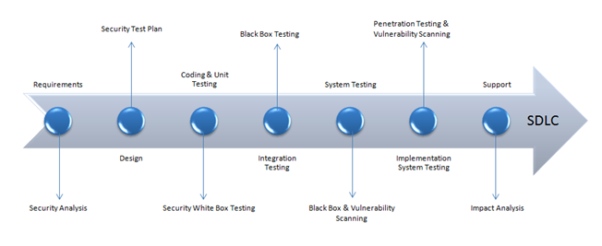Test phases in security testing
2. **Develop the detailed test plan with test cases based on quantitative risk analysis.**
3. Quantitative risk analysis
4. Functional Testing - UAT Test (5 cases).
5. Compatibility - Cross Browser Testing.
6. Performance - Load Testing / Stress Testing.
7. Usabillity - Prototyping.
8. Security - Security Testing / Spring Security.

* SQL Injection
* Logging
* Authentication and Authorization

1. Portability - Multi Platforms.
2. Reliability
3. Maintainability - Dependency Injections / JUnit Testing

|  |  |  |  |  |  |  |  |
| --- | --- | --- | --- | --- | --- | --- | --- |
| Risk No | Test Scenario ID | Test Scenario | Test Objective | Test Priority | Risk | Technique | Expected Result |
| 1 | UAT001 | Register | Registration functionality test | Medium | Data that has been registered does not enter into database | **Functional Testing** | As expected |
| 2 | UAT002 | Login | Login functionality test | Medium | Data that has been registered by the user is not found by the system | **Functional Testing** | As expected |
| 3 | UAT003 | Edit Profile | Edit profile functionality test | Medium | User data is not updated in the database | **Functional Testing** | As expected |
| 4 | UAT004 | Post Car | Post car functionality test | Medium | The post car entered by the user does not enter into the database | **Functional Testing** | As expected |
| 5 | UAT005 | Manage Post Car | Manage post car functionality test | Medium | Car post data is not found or cannot be updated in the database | **Functional Testing** | As expected |

1. **Create a test risk matrix with the evaluation of the impact.**
2. How risk evaluation is conducted

* Identify risks.

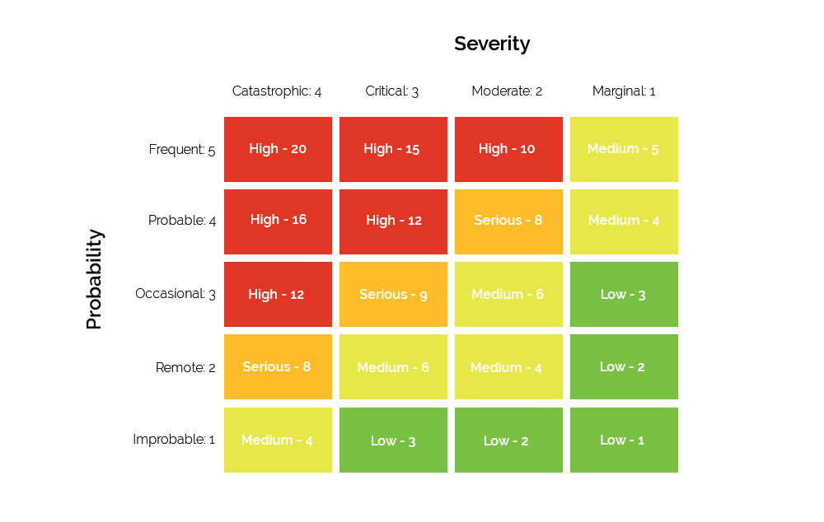

* Action Plans

Risk Action Plan is a plan of action agreed upon by an organization to help it address potential risks, reduce the likelihood of these risks occurring, and lessen the impact of these risks if they do occur.

Create action plans

1. Develop a test risk matrix for a given specification.

|  |  |  |  |  |  |  |
| --- | --- | --- | --- | --- | --- | --- |
| **Risk ID** | **Risk** | **Likelihood**  **(1-5)** | **Impact**  **(1-5)** | **Type of Testing** | **Risk Rating** | **Risk Level** |
| 1 | Users or Admins could not navigate properly using the navigation bar. | 1 | 2 | Functional Testing | 4 | Medium |
| 2 | Users could not register properly on the website | 2 | 3 | Functional Testing | 6 | Medium |
| 3 | Users could not post the car on the website | 2 | 3 | Functional Testing | 6 | Medium |
| 4 | Users could not update their personal data on the website | 2 | 3 | Functional Testing | 6 | Medium |
| 5 | Admins could not manage the car that has been posted on the website | 2 | 4 | Functional Testing | 8 | Serious |

1. Task 5

Task Statement

Create the following items under “Testing Strategy” in Project Report.

1. Design suitable RBT cycle content and priorities further test cycles.
2. Communicate the details of the strategy and test planning to the key stakeholders with proper justifications.

Solutions

1. **Design suitable RBT cycle content and priorities further test cycles.**

Based on ABC Car Sale website, below are design and explanation of suitable risk base test cycle

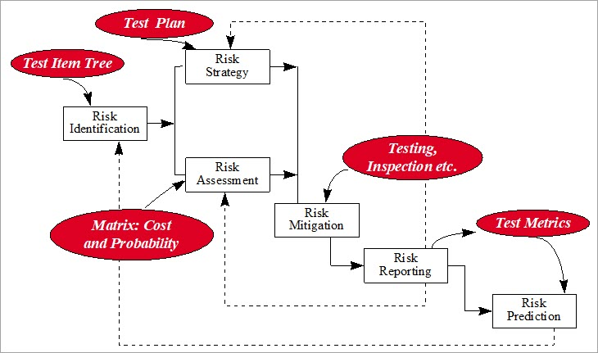

1. Identify Risk
2. Plan Risk Strategy and Assess Risk
3. Mitigate Risk
4. Report Risk
5. Predict Risk
6. **Communicate the details of the strategy and test planning to the key stakeholders with proper justifications.**
7. Justification of selected test methods based on project quantified risk

|  |  |
| --- | --- |
| **Type of Testing** | **Main Purposes** |
| Functionality | The goal of the test is to ensure that the features based on project requirements are functioning properly. |
| Performance | To ensure that the webpages' performance is consistent with the project requirement of less than 3 seconds. |
| Compatibility | Its purpose is to ensure that the website works properly across multiple browsers. |
| Usability | The primary goal is to determine whether the website interfaces are understandable and accessible to the most of  visitors. |
| Security | The main goal of the test is to identify any potential external threats that could access the website and cause exploitation. |
| Portability | The goal is to ensure that the website can be accessed from a variety of devices. |
| Maintainability | The main goal is to determine how suitable the project is for maintenance in terms of difficulty. |

1. Communicate the details of the strategy and test planning to the key stakeholders with proper justifications

* Stakeholders Identification of ABC Cars Pte Ltd
* Determine for Communication Tool
* Interview Stakeholders
* Gather Together

1. Task 6

Task Statement

Create the following items under “Testing Results” in Project Report.

1. Execute the risk-based test plan and log the test results.
2. Modify the risk-based test procedure with the reasons.

Solutions

1. **Execute the risk-based test plan and log the test results.**
2. Unit Testing

|  |  |
| --- | --- |
| **Test Scenario** | Ensure that user enters correct data in the registration page |
| TS001 |
| **Test Cases** | Unit Testing |
| TC001 | Check all the mandatory fields are entered |
| TC002 | Check if the function to add car into the database is working properly or not |

|  |  |  |  |  |  |  |
| --- | --- | --- | --- | --- | --- | --- |
| **Test Scenario ID** | **Test Case ID** | **Test Priority** | **Pre-conditions** | **Expected Result** | **Actual Result** | **Final Result** |
| TS001 | TC001 | Medium | Test using Spring Tool Suits and running with JUnit | The user information will be saved to the database after successful registration. | As Expected | Pass |
| TC002 | Medium | Add car was successful, car saved into the database | As Expected | Pass |

**Test Data Table**

|  |  |  |
| --- | --- | --- |
| **Test Scenario** | **Test Case** | **Test Data (Input)** |
| TS001 | TC001 | Username : usertest  Name : User Test  Email : [usertest@email.com](mailto:usertest@email.com)  Password : test123 |
| TC002 | Make : Honda  Model : Civic R  Year : 2018  Price : 20000 |

**Test Evidences**

|  |  |  |
| --- | --- | --- |
| **Test Scenario ID** | **Test Case ID** | **Test Evidences** |
| TS001 | TC001 |  |
| TC002 |  |

1. User Acceptence Testing (UAT)

|  |  |
| --- | --- |
| **Test Scenario** | Check that a navigation menu is provided on each page and is consistent.  Check that user can login |
| TS002 |
| **Test Cases** | Unit Testing |
| TC003 | Check each hyperlink menu is loading correct page |
| TC004 | Verify that user with valid username and password can login successfully |

|  |  |  |  |  |  |  |
| --- | --- | --- | --- | --- | --- | --- |
| **Test Scenario ID** | **Test Case ID** | **Test Priority** | **Pre-conditions** | **Expected Result** | **Actual Result** | **Final Result** |
| TS002 | TC003 | Medium | Prepare the browser by entering the website's URL. | Loaded login page  Loaded register page.  Loaded search car page | As Expected | Pass |
| TC004 | Medium | After successfully logging in, the user is directed to home page. | As Expected | Pass |

**Test Data Table**

|  |  |  |
| --- | --- | --- |
| **Test Scenario** | **Test Case** | **Test Data (Input)** |
| TS002 | TC003 | “tesla” when search car |
| TC004 | Username : usertest  Password : test123 |

**Test Evidences**

|  |  |  |
| --- | --- | --- |
| **Test Scenario ID** | **Test Case ID** | **Test Evidences** |
| TS002 | TC003 | Login Page    Register Page    Search Car Page |
| TC004 |  |

1. **Modify the risk-based test procedure with the reasons.**

Improved customer focus: Risk-based testing prioritizes thorough testing of features that directly affect customers, i.e. higher risks. This directly improves business performance, reduces the likelihood of negative reviews, and reduces the overall impact of each identified risk.

Improved software quality: Risk-based testing prioritizes higher-risk functions and ensures that the most critical functions are tested first. As a result, the software can be released with confidence that its fundamental and customer-facing functions meet quality standards.

More structured testing: Once risks have been identified and their impact quantified, it is easier to decide what to test, where to begin, and when to stop testing. In other words, it becomes easier to define the scope of testing as well as the priority of test execution within constrained timelines. This provides the framework required to organize thousands of tests in each development project.

1. Task 7

Task Statement

Create the following items under “Evaluation of Testing strategy” in Project Presentation.

1. Evaluate the effectiveness of the RBT strategy and assess the security testing cycles
2. Evaluate the testing strategies and compare its pro and cons
3. Assess the importance and environment suitability and examine the test heuristics are identified with proper justification

Solutions

1. **Evaluate the effectiveness of the RBT strategy and assess the security testing cycles**

* By implementing the risk-based approach to our software, we can experience productivity in our business.
* It gives clear information on test coverage and ensures on-time delivery.
* Using the risk-based test approach, the testers will let you know the changes needed to make in a software or application.
* Certain background checks are made with the help of risk testing to ensure that the app and the inner functions will fully work.
* The risk-based testing model is designed to improve market opportunity, service performance, and for giving cost reduction benefits.

1. **Evaluate the testing strategies and compare its pro and cons**

Pro:

* Highly efficient
* Quality
* Satisfies customer
* Good product, good revenue
* User experience
* Business optimization

Cons :

* Appropriate communication and coordination with the tester
* Competition among similar service providers
* Lack of experienced professionals
* Finding the right service provider

1. **Assess the importance and environment suitability and examine the test heuristics are identified with proper justification**

**Error prevention:** Plan for and anticipate mistakes. Eliminate them where possible, and ensure that users can easily recover from errors in other cases.

**Flexibility and efficiency of use:** Allow users to customize or tailor the interface to their needs in order to perform common actions more easily.

**Help and documentation:** Make documentation easily accessible and searchable.

1. Task 8

Task Statement

Provide screen capture of developed pages and hosted application in Project Presentation

Solutions

Register Page  
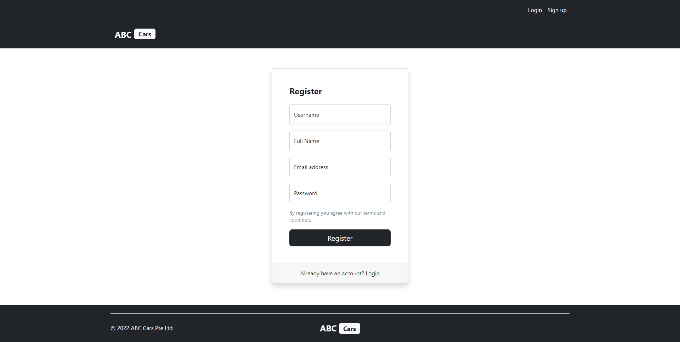

Login Page  
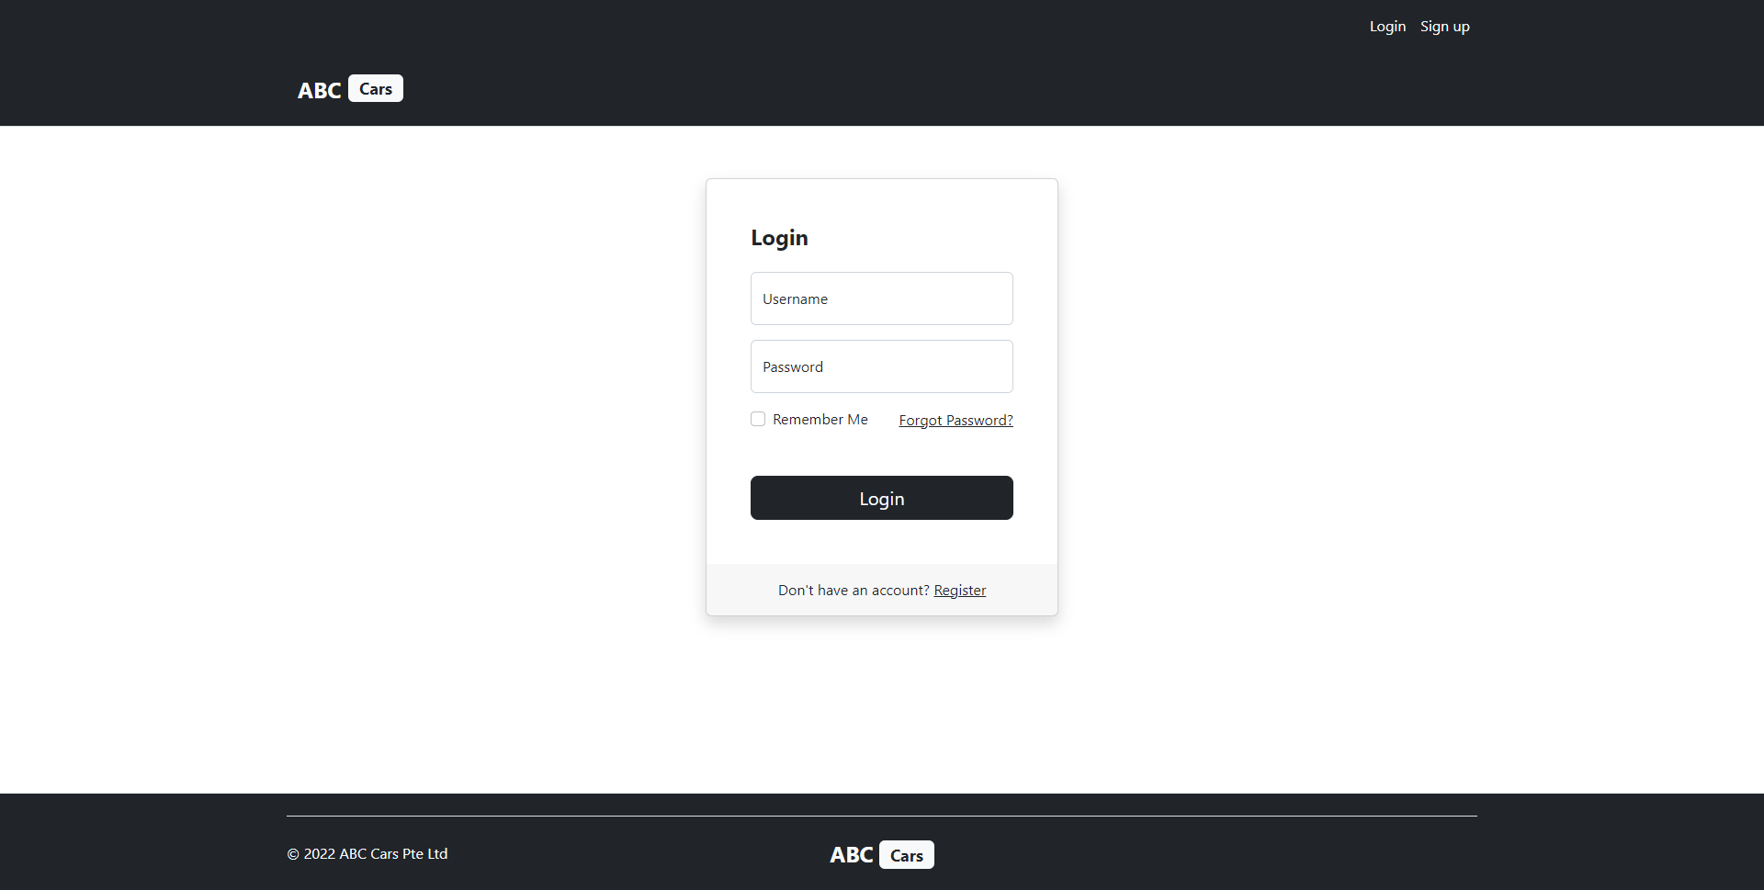

Home Page (user)  
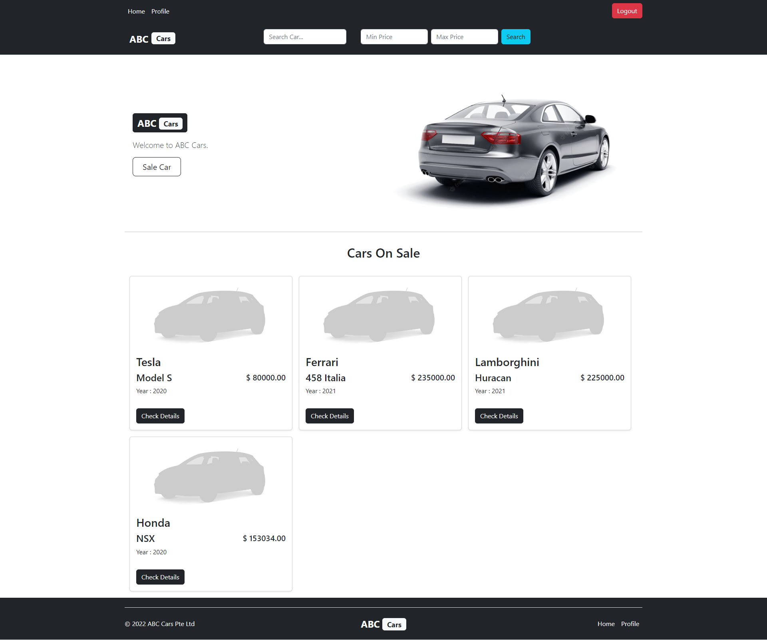

Profile Page  
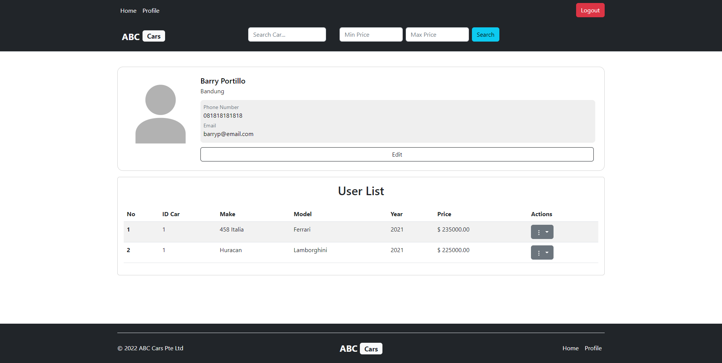

Edit Profile Page  
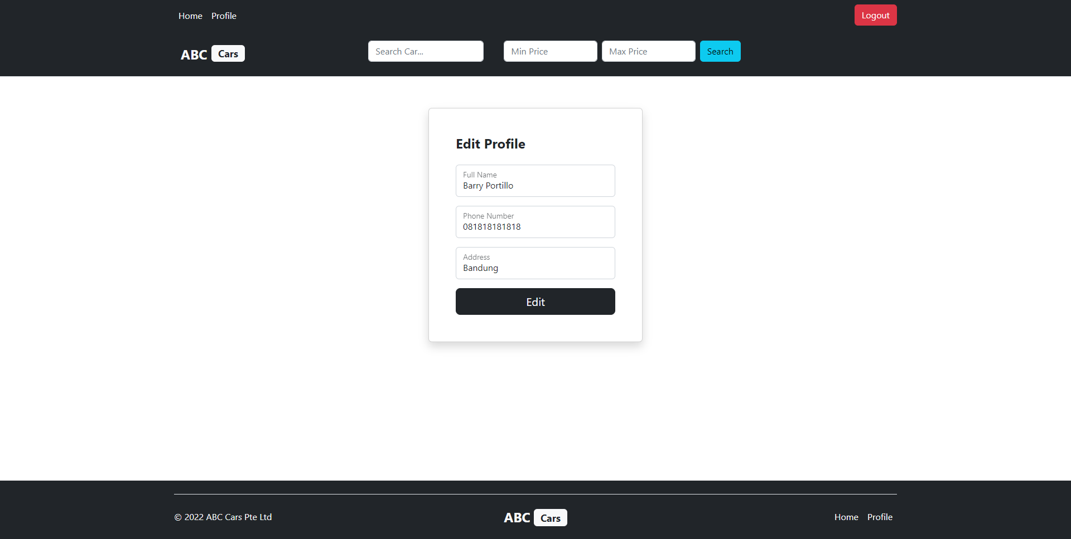

Post Car Page  
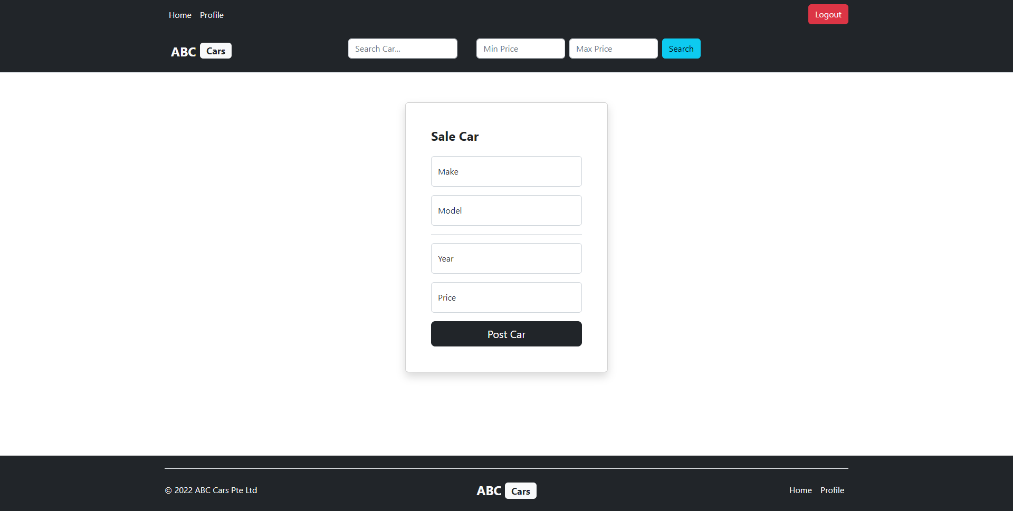

Detail Car Sale & Bidding Page

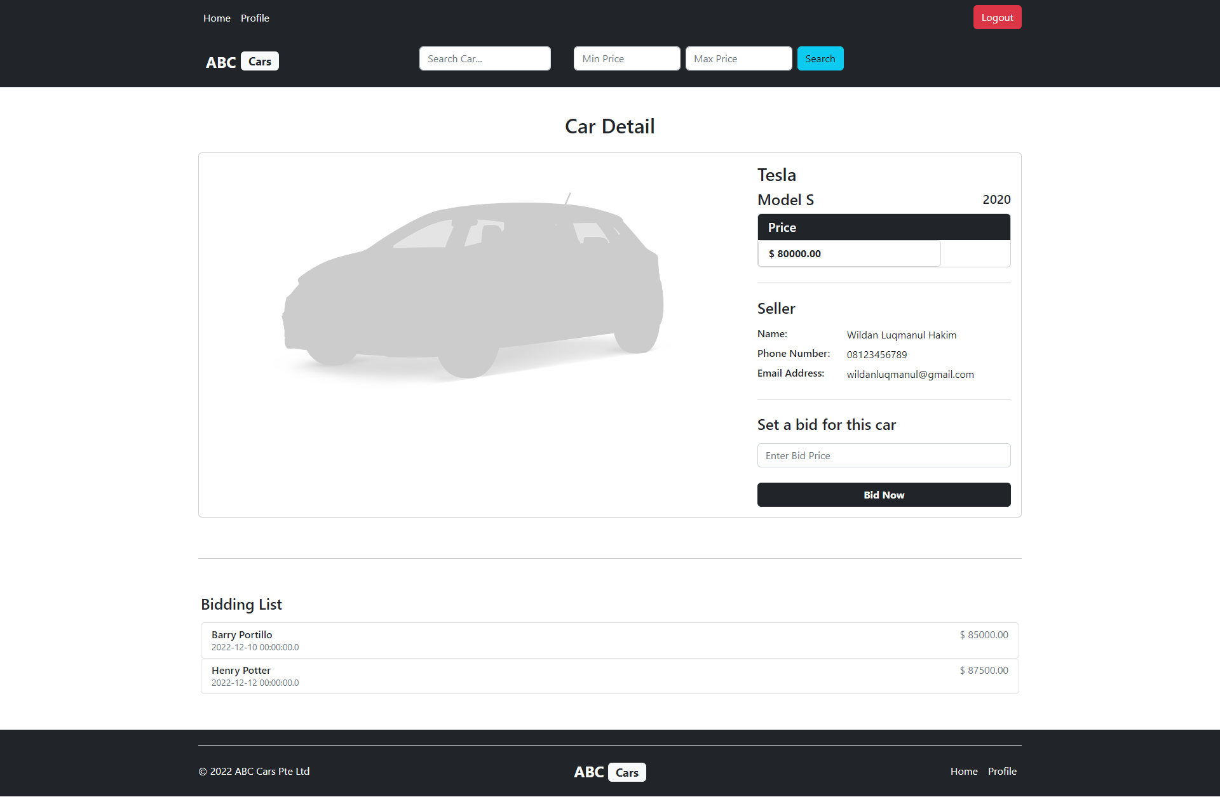

Edit Car Sale Page

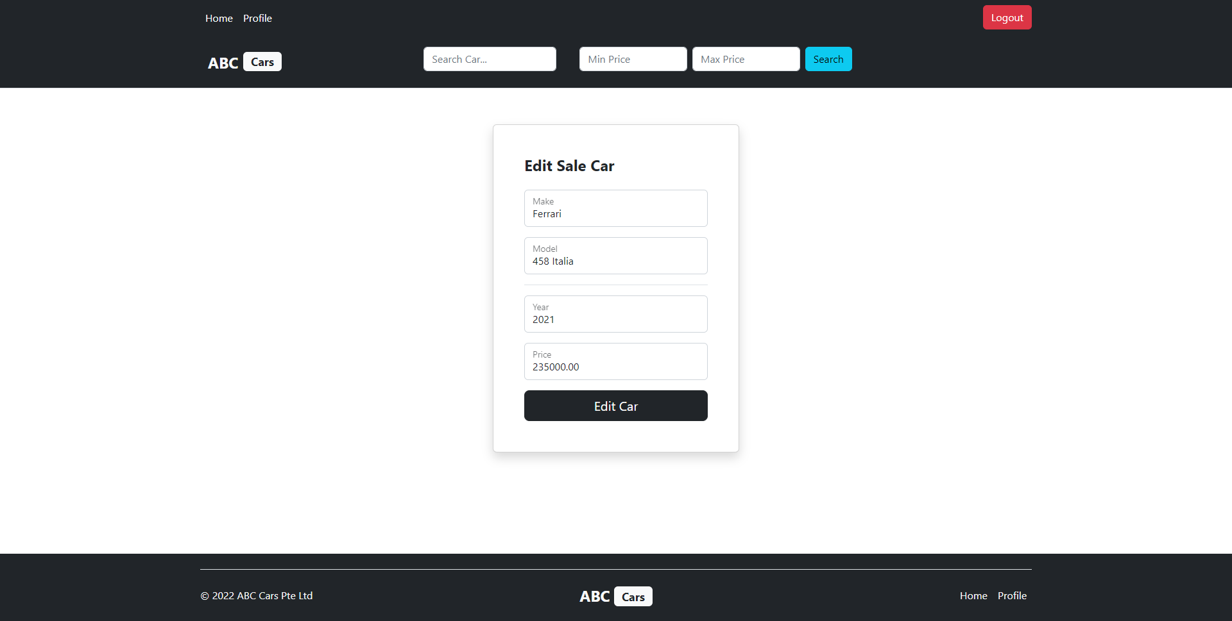

Search Car Page

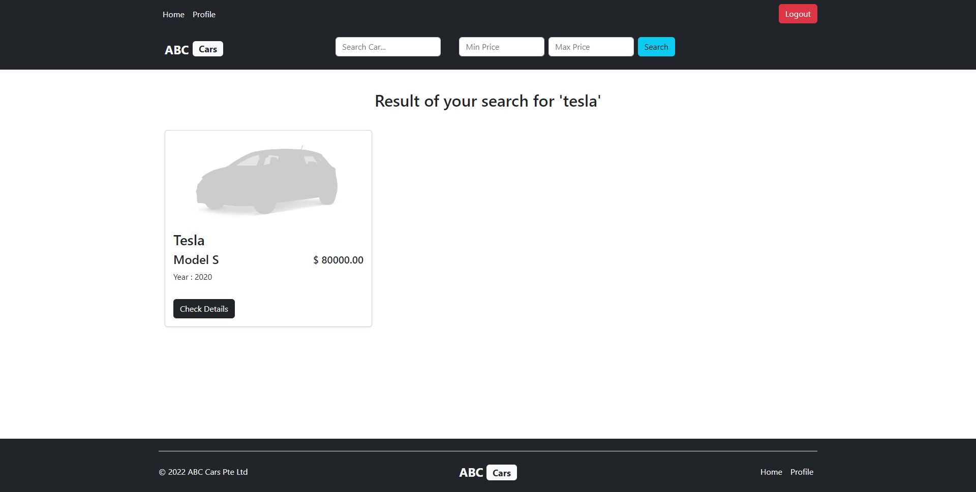

Home Page (admin)

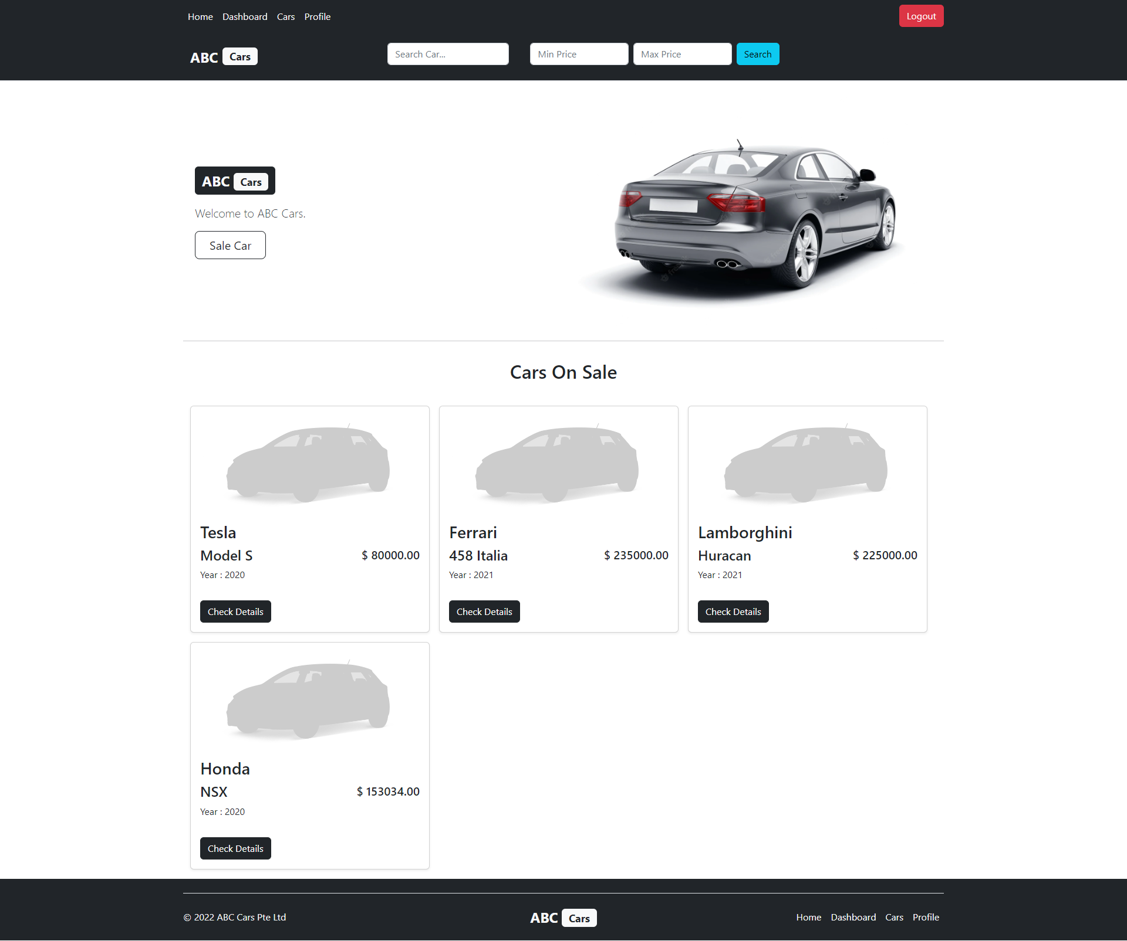

User List Page

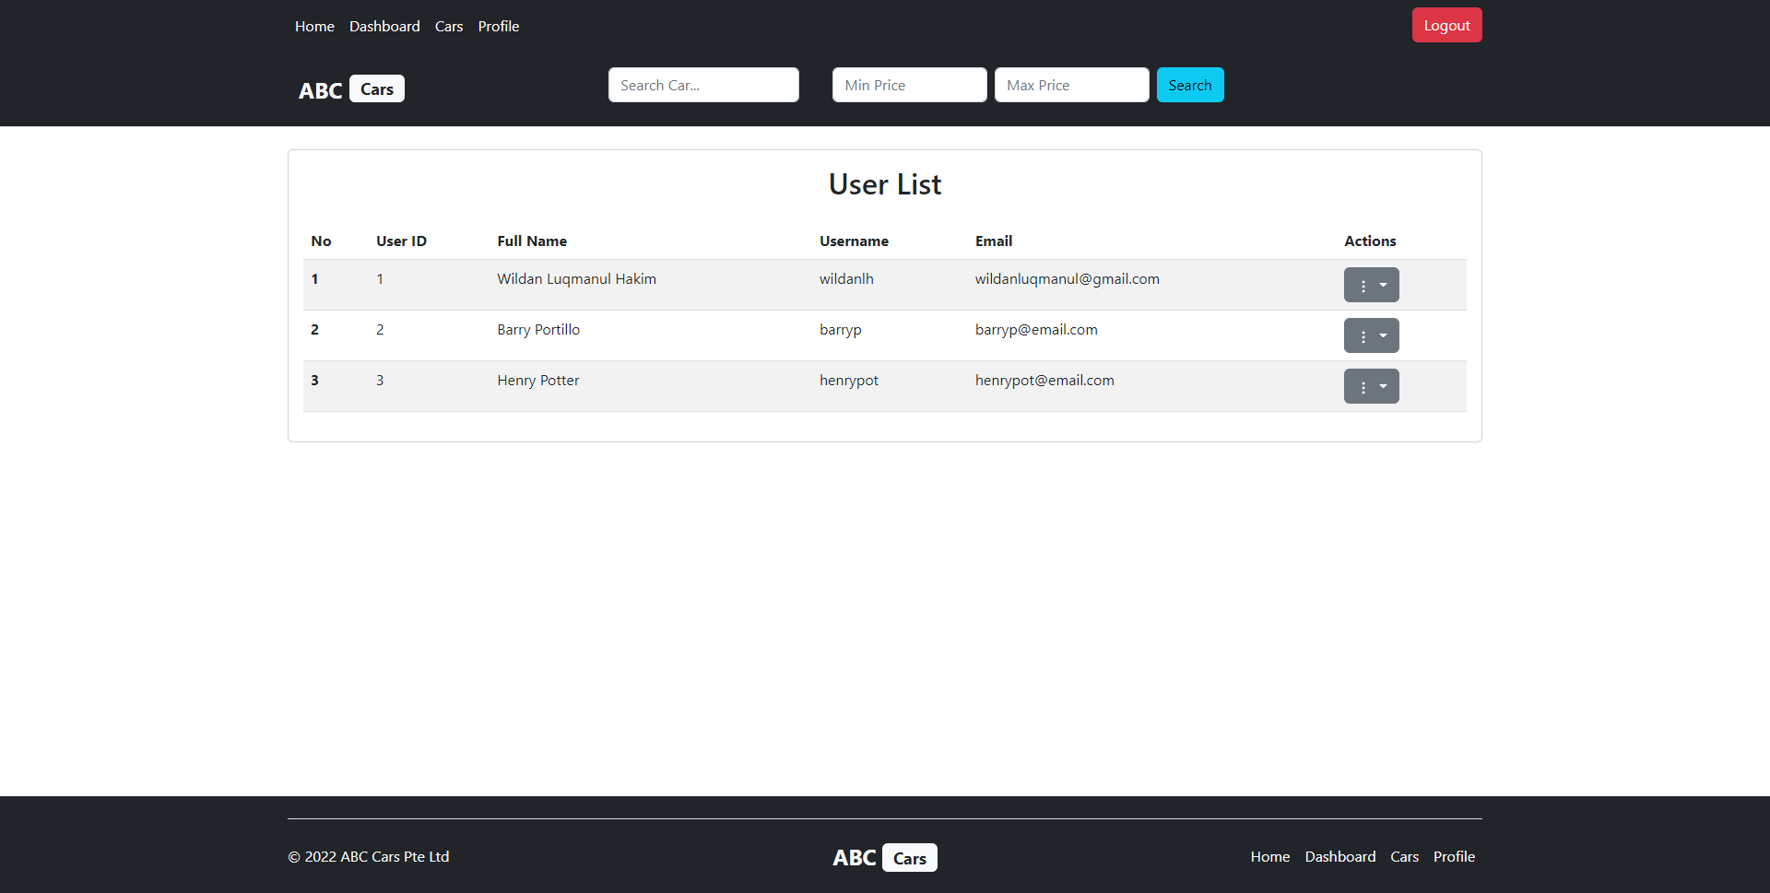

Edit User Page

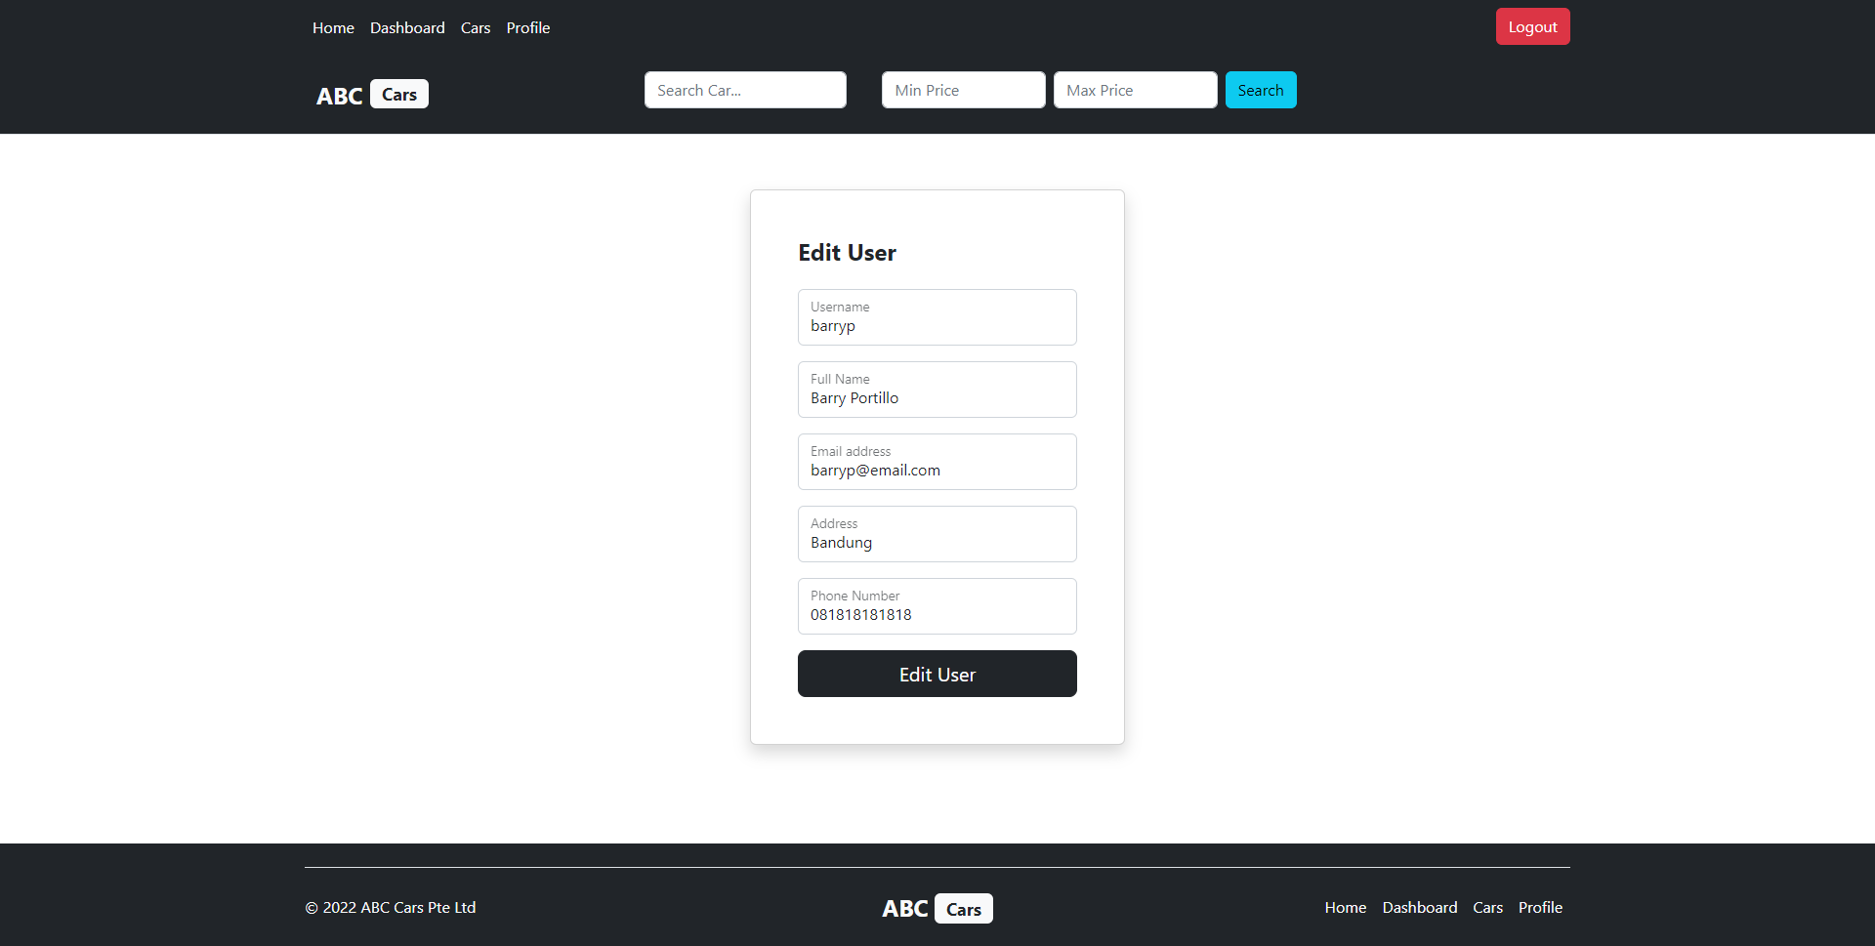

Car List Page

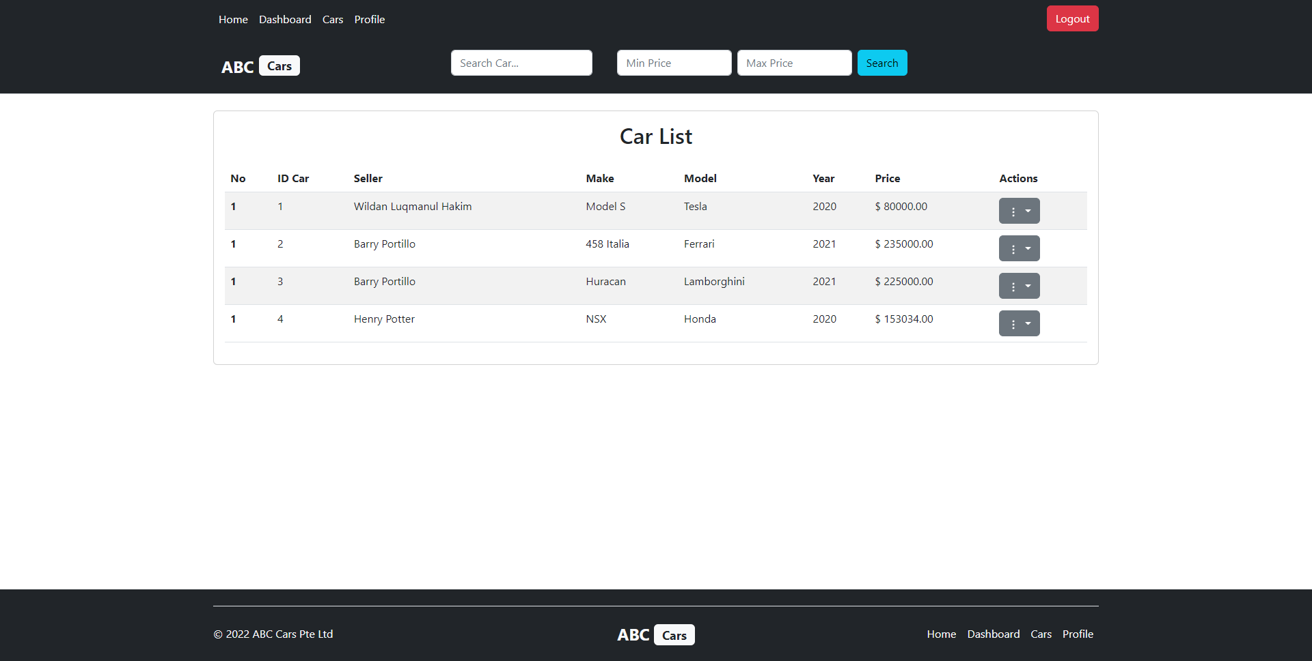

Thank You Page

